Plans for making a model paddle steamer
Based on the PS Pevensey

By Ross Callaghan
http://rosscallaghan.yolasite.com rosscallaghan@gmail.com

These plans will enable you to make a model paddle steamer similar to the PS Pevensey, now working the Murray River out of Echuca, Victoria, Australia.

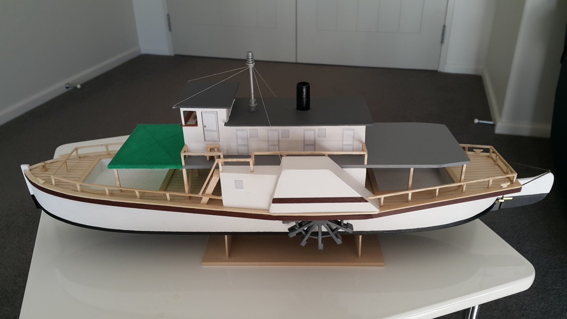

Before starting to make the model see the YouTube clip “Building the model paddle steamer PS Pevensey” at https://www.youtube.com/watch?v=MMc83Hqs-fU or by searching for calros3.

These plans were drawn up after making the model so adjustments will be needed during the build!

Stage 1: Creating the hull
- Print the plan and join Hull –Sheets 1 and 2 with cellotape.
- Cut out the template for the deck and for the keel/ frame (at the darker lines).
- Attach the deck plan to a sheet of 3mm balsa and cut out around the outer edge, then cut the holes for the two hatches. This forms the false deck.
- Draw the lines for the shape of the hull on the under surface of the false deck.
- Attach the deck plan to a sheet of 1mm basswood and cut out the deck and the holes for the hatches. This forms the deck. Draw parallel pencil lines on the top surface of the deck 5mm apart to simulate planking.
- Attach the keel/frame plan to a sheet of 3mm basswood and cut out the keel/frame. Follow the darker lines, including cutouts for the two hatches.
On the plan the basswood is described as 1mm or 3mm in diameter. Actually it comes in sheets which are 1/16” (about 1.5mm) or 1/8” (about 3mm) in diameter. These 1/16” and 1/8”sheets are the ones that are used in making this model paddle steamer.
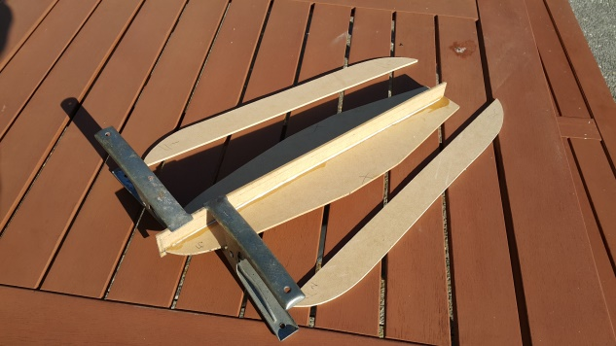
- Glue the keel/ frame to the under surface of the false deck, making sure it is centred and square.
- Hold pieces of 3mm basswood against the under surface of the false deck and transcribe its shape onto the basswood. Cut out the two halves of the false bottom making sure they are 1mm less than the deck all around their outside. This will ensure the sides bevel inwards slightly. See “Cross section of hull” on Sheet 3.
- Glue the deck on top of the false deck.
- Create half bulkheads from 3mm basswood for the positions indicated on the plan. The bulkheads are 28mm deep in the middle and 27mm deep at the front and back, so the false bottom is raised slightly at both ends. The bulkheads should be flush with the deck/ line at the top and 1mm less at the bottom, to match the halves of the false keel.
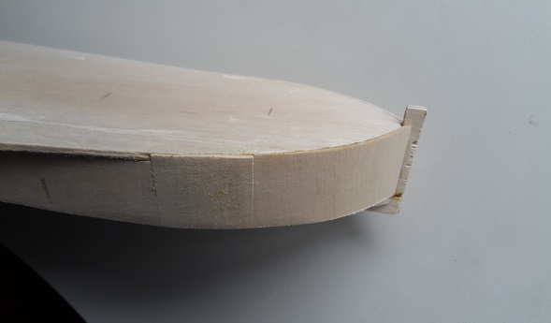
- Glue the bulkheads in place, and then create packing for attaching the sides to the deck between the bulkheads. The packing should follow the lines drawn on the under surface of the false deck.
- Glue on the two halves of the false keel.
- Glue the sides on all the way round using 1mm basswood. This may need to be done in sections and the basswood may need to be cross grain for the curves at the front and the back. The top of the sides should be flush with the top of the deck at the front and butt up to the bottom of the false deck following the line at the back. Trim and sand at the bottom so the sides are flush with the false bottom.
- Hold sheets of 1mm basswood in place on both sides of the keel and mark the two halves of the bottom. Cut so there is a little extra which can be sanded off later. Create packing alongside the centre keel to enable the bottoms to be raised slightly in the centre, but tapering upwards at the front and back, as shown on the plan. Glue the two sides of the bottom in place and sand so the edges with the sides are smooth.
Keel
- Sand the hull smooth and use a filler like Polyfilla to cover any imperfections. Sand until everything is smooth.
Bottom in place
Packing
The better this is done, the better the model will look in its finished state.
- Create bottoms and sides for both hatches from a sheet of 1mm basswood and glue in place. Some packing may be needed underneath.
- Paint the hull and inside the two hatches using white acrylic paint. (3 coats). Leave the deck unpainted.
- Create 5mm wide strips of 1mm basswood and glue in place around the top of both hatches.
- Create 5mm wide strips of 1mm basswood for the side edges and the top edges of the deck. (Leftover pieces from when the deck was cut may be the right shape for the deck’s top edges). Pre-paint the side edges with burnt umber acrylic paint. The top edges are not painted. Glue the side and top edges in place, except in the space for the paddle housing. See “Cross section of hull” on Sheet 3.
- Build a stand to hold the hull (and, later, the completed model).
The hull is now complete, except for painting of the bottom with black acrylic paint. (Done later).
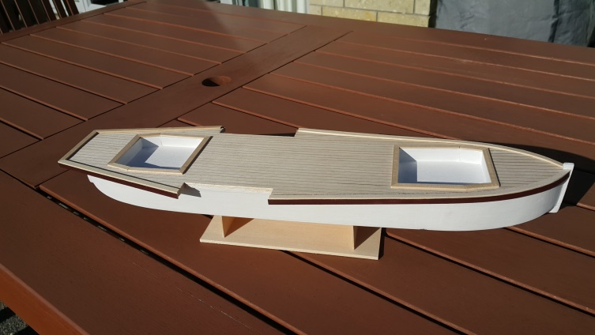
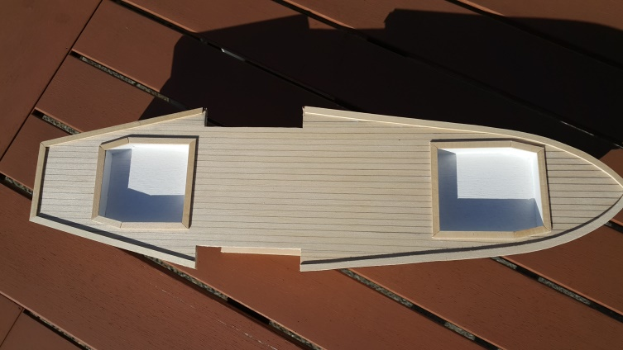
Stage 2. Creating the top deck, cabins and bridge.
- Cut out the template for the top deck. Attach it to 3mm basswood and cut out the top deck. Paint the top deck light grey.
- Cut out the templates for the sides (2); upper and lower front of bridge; front of cabins/rear of bridge, rear of cabins; roof of bridge, and roof of cabins. Attach to a sheet of 1mm basswood and cut out each panel.
- Glue the panels for the cabins/bridge together, using packing on the inside corners. (i.e upper and lower front of bridge; front of cabins/rear of bridge (with window cut out); rear of cabins).Don’t attach the roof of the cabins or bridge till later.
- Insert a piece of 1mm” balsa to form the corners of the bridge window.
- Cut out the bridge doors, and keep the pieces for attaching later.
- Create a false floor for the bridge just under the level of the bridge door. Use packing for support then glue in place.
- Create a front shelf for the bridge and a simulated helm and glue them in place.
- Paint the cabins and bridge white. Also the two bridge doors. (3 coats).
- Print the stencils for the cabin windows and doors, the bridge doors and the name of the paddle steamer and glue in place.
- Glue a piece of white paper to the back of the bridge doors and the inside of the bridge so the bridge doors are held in place and can open and shut.
- Paint the cabin and bridge rooves dark grey.
- Glue the cabin and bridge rooves in place.
- Create a ledge for the bottom of the bridge window using thin brown trim.
- Create a funnel from a suitable 10mm diameter tube (e.g. the centre of a cotton reel). It should be 25mm above the roof and long enough to reach down to the top deck. Cut a hole in the cabin roof and glue the funnel in place. Paint the funnel black.
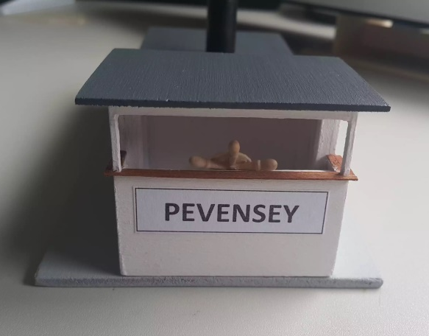
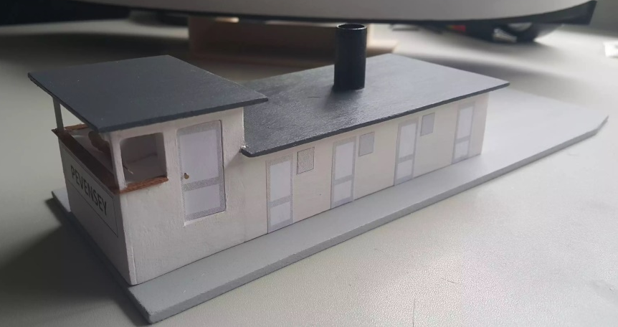

Stage 3. Creating the lower deck, toilet and paddle housing
- Cut out the templates for the pieces of the lower deck/engine room, (2 ends and 2 sides), toilet (2 sides) and paddle housing (2 inside and 2 outside) from Sheet 3. Attach them to 1mm basswood and cut out each panel.
- Glue the panels for the lower deck/engine room together, using packing on the inside corners. See Sheet 1 and 2 for how they are positioned. The floor of the top deck will sit directly on top of the sides of the lower deck/engine room so make sure they are flush with it. (The front of the lower deck/engine room extends out to form the front of the toilet). Cut little notches on the bottom corners of the front of the lower deck/engine room so they fit into place on the deck at the position shown on the plan.
- Cut out the toilet doors and then paint the lower deck/engine room and toilet doors white. (3 coats). Glue on the template for the toilet door and attach the doors using paper glued on the back as before.
- The next bit is a bit tricky! Place the lower deck engine room in place on the hull and then hold the inside and outside paddle housing sides in place. Make sure they line up and then glue the inside paddle housing to the outside of the lower deck/engine room. Create top and sloping sides for each paddle housing and glue in place.
- Cut out sides for the toilet and glue in place so they butt up to the front of the paddle housing. The sides of the toilet sit on the deck top edge about 3mm in. Create a top for the toilet, making sure that it will sit flush with the floor of the top deck, once it is in place. See Sheet 3.
- Repeat for the other side.
- Create a frame for the steam engine using 1/16” balsa, and find a suitable engine (e.g. a cut back model train engine).
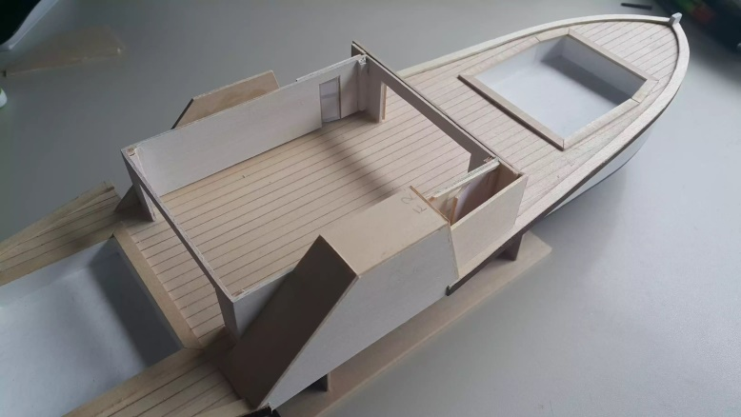
- Finally sand, fill and paint the lower deck/engine room, paddle housing and toilet unit, making sure it fits in place on the deck, and that the top deck fits securely in it.
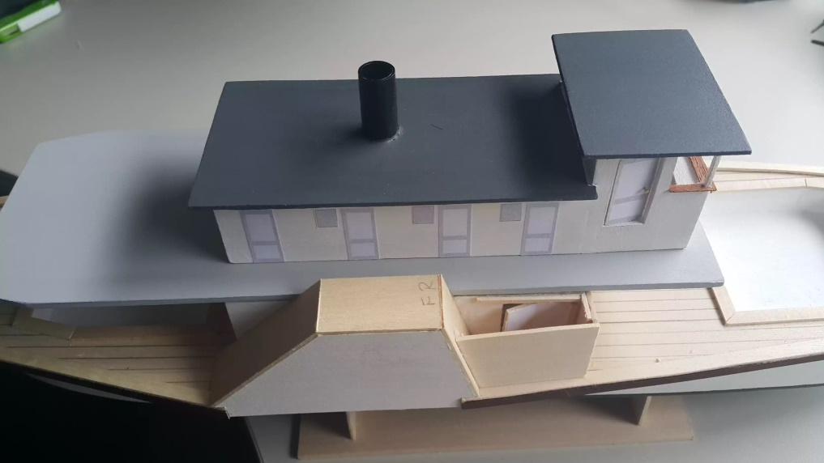
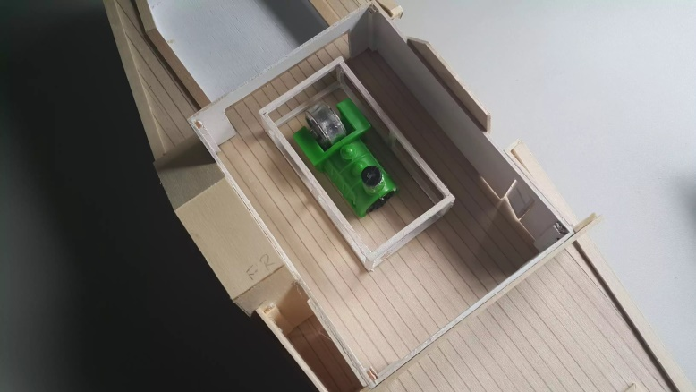

Stage 4. Creating the paddles.
The paddles are a bit tricky to make, but take your time and they will come together and look very similar to the ones on the original paddle steamer.

- Cut two pieces of 15mm dowel (or similar round material) each 10mm long. These form the central hub of the two paddles.
- Cut 48 pieces of 1/16”square balsa, each 25mm long. These form the spokes for the paddles.
- Cut 48 pieces of 1mm basswood, each 8x10mm. These form the supports for the spokes.
- Cut 24 pieces of 1mm basswood, each 6x10mm. These form the paddles.
- Place the “Template for paddles” from Sheet 5 on a soft board and cover with glad wrap. Pin in place so the surface is smooth.
- Place one of the pieces of dowel in the centre of the template, then glue and pin 12 spokes around it.
- Glue the 12 supports in place on top of the spokes. Make sure they are glued as close as possible to a circle in shape.
- Glue the 12 other spokes to the top edge of the dowel and on the supports, lining up with the spokes underneath.
- Glue the 12 paddles in place on the clockwise side between the end of the two spokes. Try to get a nice smooth surface between the dowel and the spokes, but this can be smoothed later with a filler if necessary.
- Remove the paddle from the template when all is dry.
- Repeat steps 1-10 for the other paddle, but this time attach the paddles to the anticlockwise side.
- Cut a piece of 3mm dowel (or similar material) 110mm long. This will form the axle between the two paddles.
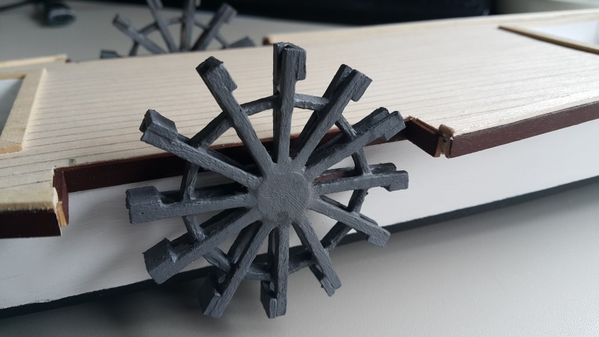
- Drill out the centre of the dowel on the inside of each paddle to a depth of 5mm and a width to suit the width of the axle. Adjust so the paddles will sit centred in the paddle housing when fitted.
- Paint the paddles grey.
- Pre-paint pieces of 5mm basswood in burnt umber and glue in place around the cutout for the paddle housing, to complete the side edges.

Stage 5. Completing the painting.
At this stage the hull is pretty much complete and the upper and lower decks and the paddles are all complete and painted, ready for assembly. It is now time to complete the painting of the hull.
- Glue on stencils for the “windows” of the toilet.
- Apply masking tape over the white paint of the sides along the waterline (equivalent to the dotted line on the keel/frame plan at the top of the false keel). Bring the masking tape upwards slightly towards the bow and the stern and then horizontal as it goes around the protruding parts of the bow and stern. Make sure the masking tape is firmly attached so no paint can get under it.
- Apply 3 coats of black acrylic paint to the bottom and up to the masking tape. Remove the masking tape when the paint has dried thoroughly.
Stage 6. Creating and fitting the rudder.
- Cut out the plan for the rudder and attach it to a piece of 3mm basswood. Cut out the rudder to shape, including the notches for the hinges.
- Sand the rudder smooth and paint it so the white and black of the hull line up horizontally.
- Make2 pieces of thin aluminium or copper or brass foil 25mm long x 2mm wide and 2 pieces 30mm long x 2mm wide.
- Create a furrow in the leading edge of the rudder 22mm long and glue in a piece of thin aluminium or copper or brass wire.
- Bend the foil and glue in place to create a hinge for the rudder. The longer foil goes on the bottom.
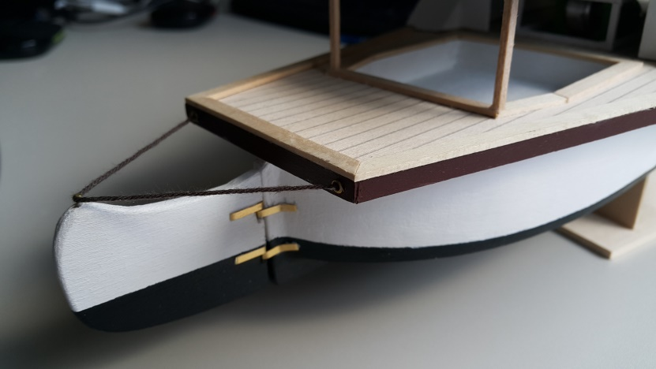
- Insert a pin on the top of the rudder and create two holes in the back of the deck. Glue thread into these holes and around the pin to simulate the rudder control wires.

Stage 7. Assembling the model.

- Drill a hole through the hull to take the axle for the paddles. The hole should be aligned as per the plan and just below the false deck.
- Glue the axle to one of the paddles and thread through the hole then place the other paddle in place. Identify the size of washer that will be needed so the paddles sit in the middle of the paddle housing, and create these washers out of round plastic e.g. from a pen or similar plastic tube. Adjust the length of the axle if necessary.
- Assemble the paddles with the washers and glue the other paddle in place. The paddles should rotate freely and not touch the paddle housing.
- Glue the lower deck/engine room/paddle housing/toilet unit in place on the deck.
- Glue the top deck/cabins/bridge unit onto the lower deck/engine room unit.

The model is starting to look pretty good right now!
Just add all the finishing touches, and it will be complete.

Stage 8. Completing all the finishing touches.

- Make the steps for the bridge and between the decks. Use 5mm wide 1mm basswood.
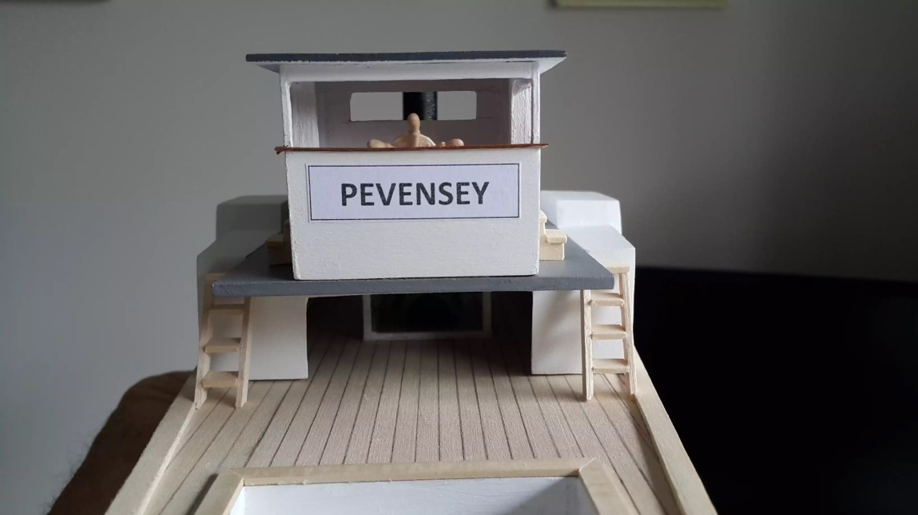

- Cut about 50 pieces of 1/16” square balsa, each 10mm long. These are the posts for the rails on the sides and on the upper deck.
- Create the rails for the rear of the boat using 1/16” square balsa and glue in place. Also glue in posts to hold the rear part of the upper deck, using 3mm square balsa.
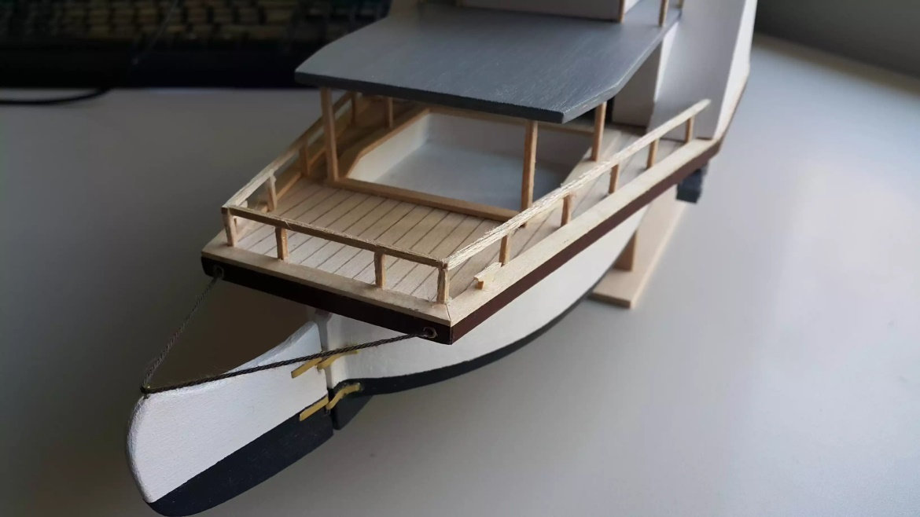

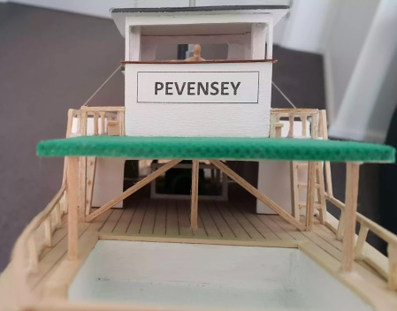
- Create the front hatch cover from 5mm wide 1mm basswood in two layers. See Sheet 5 for dimensions. Cover with green fabric and glue in place at the front of the top deck. Use 3mm square balsa for posts and for the supports under the bridge.

- Create the rails for the front of the boat and glue in place. Also create the rails for the upper deck and side of the stairs and glue in place. Use 1/16” square balsa.
- Create the 4 cleats and the bollard and glue in place.
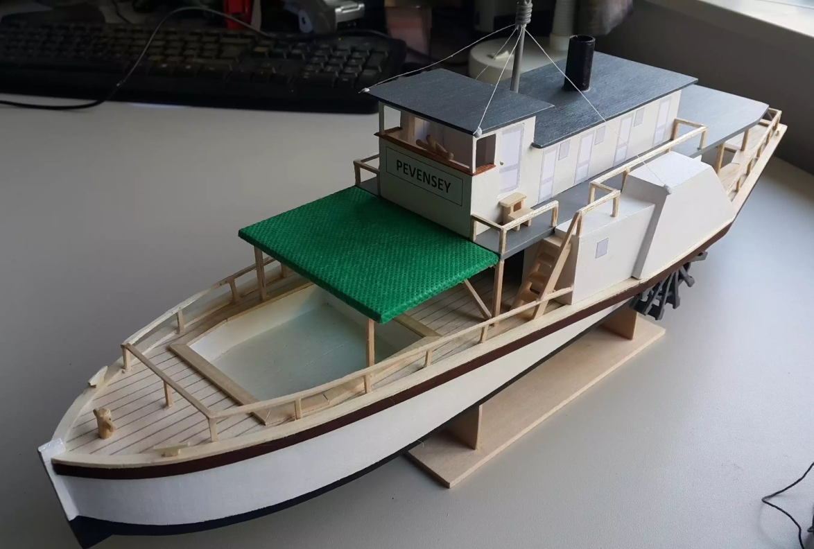

- Find a suitable aerial and glue in place on the roof of the cabin. Glue in cotton supports to the front of the bridge and the outer front of the paddle housing.
- Pre-paint 5mm wide side edges for the paddle housing. Sand smooth and glue in place. Attach a 1mm basswood strip above the side edge here, so that the top edge of the deck is continuous. Attach thin trim in burnt umber to the side of the paddle housing.
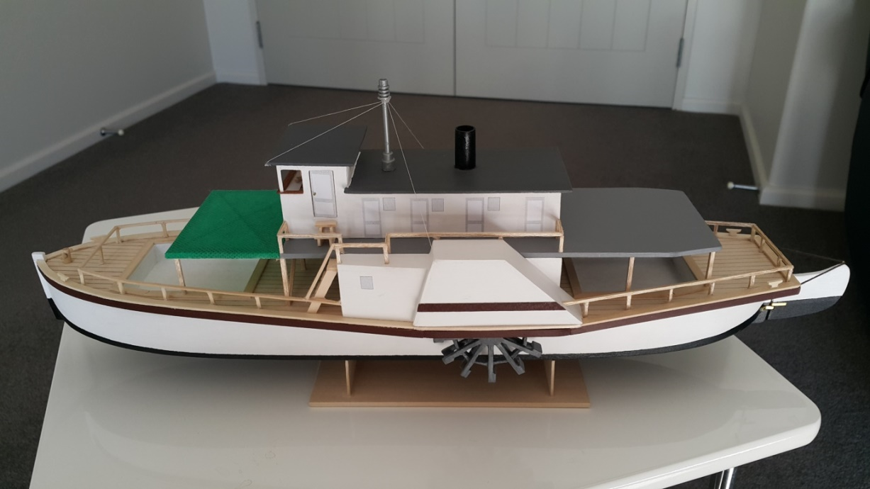

Your model is now complete! Be prepared for lots of oohs and aahs when you show it off!

Please send a photo of your model to rosscallaghan@gmail.com and any comments.
About the PS Pevensey

The PS Pevensey was built in Moama in 1911 and was named after the Pevensey Station on the Murrumbidgee River. She was used to pick up wool bales from stations along the Murray River and bring them to the Echuca Wharf for transport by train to Melbourne. She could carry 815 bales on the boat itself and a further 1185 bales when towing the barge Ada.
The PS Pevensey was almost destroyed by fire while at Koraleigh landing on the 11th October 1932. The fire occurred at night and the captain and his wife and crew were able to make it through the fire to shore safely. The PS Pevensey was rebuilt using cabins from PS Decoy at Morgan in South Australia. The repairs were estimated at £6,000. She was then used for regular runs on the Murray River through till 1963, when she lay idle at Renmark.
In 1973 the PS Pevensey was purchased by the Echuca City Council and was accurately restored at Moama. Each piece of timber on the hull was matched exactly to the original using original techniques. She uses one ton of red gum logs per hour under full steam and can travel at 12km/h downstream. She still runs the original steam engine, a 2 cylinder from Marshall and Sons. In 1982 & 1983 she played the role of PS Philadelphia in the mini-series ‘All the Rivers Run’.
Today, the PS Pevensey is working the Murray River from the Echuca Wharf, but she is now a tourist attraction. She can take 100 passengers.

Stencils for doors and windows

PEVENSEY
Cabin and toilet windows

Bridge door
Cabin and toilet door

This plan for the paddlesteamer PS Pevensey was created by Ross Callaghan in 2016.
It is at a 1:67 scale.


